

SESSION DE : AVRIL 2018 CENTRE : BORDEAUX

CODE DE L’UE : LMA2Y11 - MATIERE : LMA2Y113 – Langue Anglaise 2 - CM
et
CODE EPREUVE : LMA2M113E1 - Langue Anglaise 2 - CM

Nature de l'épreuve : QCM (30 questions) | Durée de l'épreuve : 1 heure
Documents non autorisés

Questionnaire à réponses multiples

Répondez aux questions en cochant la ou les bonne(s) réponse(s) sur la grille de réponses fournie séparément.
Une seule grille de réponses vous sera délivrée. Veuillez donc bien prendre connaissance des instructions avant de la compléter.

Consignes de remplissage de la grille de réponses :

- Compléter vos coordonnées.  - Reporter votre numéro d’étudiant et cocher les cases correspondantes à votre numéro d’étudiant.  - Pour chacune des questions, vous devrez noircir (uniquement en noir ou en bleu) la case correspondante à votre réponse sur la première ligne.  - Pour corriger votre réponse, utilisez la deuxième ligne sans cocher « annul ». Seule cette deuxième ligne sera prise en compte au moment de la correction, quel que soit le marquage de la première ligne.  - Pour que la totalité de vos réponses de la 1ère et de la 2ème ligne soit annulée, cochez la case « Annul.» se trouvant sous le numéro de la question. Ceci équivaut à une absence complète de réponse. |  | 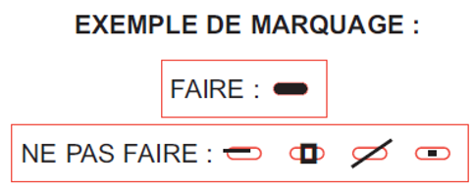  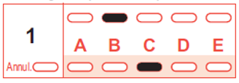  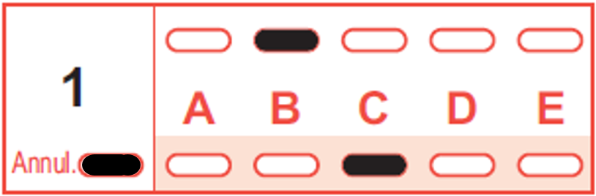 |  | 1ère ligne  2ème ligne  1ère ligne  2ème ligne
Le barème est le suivant :

Type de réponse | Nombre de points
Réponse juste | + 3
Réponse fausse | - 1
Absence de réponse | 0
Réponses incomplètes | Comprenant uniquement des réponses justes : nombre de points proportionnel au nombre de réponses justes.
Réponses incomplètes | Comprenant au moins une réponse fausse : nombre de point = 0

ENGLISH PRONUNCIATION

1. Which of these words starts/start with the sound /ə/?
a) Altar
b) Annoy
c) Attention
d) Autonomy

2. Which of these sounds is used to pronounce the vowel in the word “home”?
a) /ə/
b) /əʊ/
c) /ʌ/
d) /ɑː/

3. Which of these words is/are stressed on the first syllable?
a) Imagine
b) Conspiracy
c) Catholic
d) Permission

4. Which of these words is/are stressed on the second syllable?
a) Protestant
b) Japan
c) Obvious
d) Permanent

5. Which of these words is/are stressed on the third syllable?
a) Significant
b) Employee
c) Redundant
d) Dedication

6. Which of the following phonetic transcriptions is the correct one for the word "developed"?
a. /ɪntəːsɛpt/
b. /ɪntəːsɛpd/
c. /ɪntəːsɛptɪd/
d. /ɪntəːsɛpted/

7. Which of the following phonetic transcriptions is the correct one for the word "pressed"?
a. /prɛst/
b. /prɛsd/
c. /prɛsɪd/
d. /prɛsed/

8. Which of the following words uses/use the vowel sound which is represented by the symbol /ɜː/?
a. blunder
b. term
c. door
d. bird

9. Which of these words does/do NOT feature the sound /ə/?
a) Profitable
b) Mentality
c) Problem
d) Reality

10. Which of these words features/feature the sound /ə/ twice?
a) Chocolate
b) America
c) Completion
d) Department

ORAL COMPREHENSION

11. Eureka Valley was the original name of the San Francisco area now known as … ?
a) Golden Gate Park
b) The Tenderloin
c) Hunter’s Point
d) The Castro

12. Which city was the video focusing on illegal immigration set in ?
a) Los Angeles
b) San Francisco
c) Austin
d) New York

13. You were shown a video about parents disapproving of abortion protests in … ?
a) Texas
b) California
c) New York
d) Kentucky

14. The video on New York deals with and outbreak of …?
a) Measles
b) Small pox
c) The flu
d) Whooping cough

15. In the video about domestic violence in Kentucky, how did Pam, the police officer, die?
a) She was drowned in a lake
b) She was shot in the head
c) She died in a car crash
d) She was stabbed in the back

16. In Kentucky, what do police officers use when called out on a domestic violence case?
a) Handcuffs
b) Tear gas
c) Machine guns
d) A check list

17. In Texas, those who protest against abortion are called… ?
a) Abolitionists
b) Pro-lifers
c) Creationists
d) Mormons

18. The video on Washington D.C illustrates how the city deals with the issue of …?
a) Education
b) Unemployment
c) Drugs
d) AIDS

19. What took place in San Francisco in 1967?
a) The assassination of Martin Luther King
b) U.S. troops use their rifles in an encounter with anti- Vietnam-war demonstrators
c) The summer of love
d) Ronald Reagan became the 33rd Governor of California

20. In the video you saw about abortion in Texas, the signs outside the school displayed pictures of… ?
a) New-born babies
b) Foetuses
c) Traditional families
d) Priests and nuns praying together in a church

CULTURE and PUBLIC HEALTH

21. Which of these is/are located in Washington DC?
a) The National Mall
b) Central Park
c) Alcatraz
d) Coney Island

22. Which of these is/are located in New York City?
a) Little Italy
b) Capitol Hill
c) The Empire State Building
d) Union Station

23. Which of the following is/are true about the Affordable Care Act?
a) Abortion will be available to all women under 25 for free
b) Most Americans will be required to have some form of health insurance
c) Insurers will have to publicly justify rate increases of over 10 percent
d) People over 80 and under 20 get free health insurance

24. Which of the following is/are associated with Austin?
a) The Colorado River
b) The International Institute of Criminal Justice
c) Mormons
d) Mount Rushmore

25. Which of these services does Planned Parenthood NOT provide in TEXAS?
a) Abortion
b) HIV tests
c) Birth contol
d) Drug rehab

26. Which state is Hopkinsville in?
a) Kentucky
b) Texas
c) New Jersey
d) West Virginia

27. Which of the following is/are located in Los Angeles?
a) The Lincoln Memorial
b) Griffith Park
c) The La Brea Tar Pit
d) Union Station

28. Which of these does the San Francisco Drug Users' Union provide?
a) Free drugs
b) Rehab facilities
c) Supervised self-injection sites for heroin users
d) Low-rent appartments for reformed addicts

29. Which of these is/are located in San Francisco?
a) Capitol Hill
b) The Castro
c) The Golden Gate Bridge
d) The Smithsonian Institute

30. Which of the following is/are associated with UCLA?
a) The Campanile
b) De Nev Plaza
c) Sunset Village
d) The Tenderloin

